# Installing Node

First navigate to the node.js website, you may find the documentation here useful in the future.

<https://nodejs.org/en/download/>

Download the correct version of Node for your machine, for the Academy PC’s it should be the 64-bit .msi, the LTS is recommended for its stability.

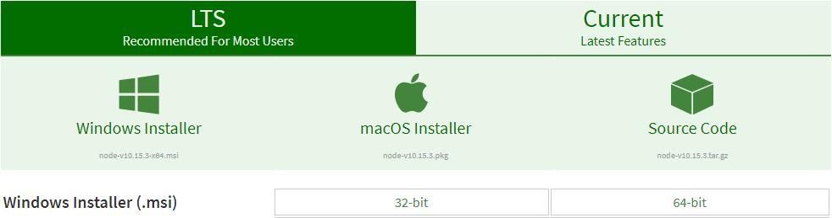

Once this has downloaded it is a simple process of running the file and following the instructions. Follow the wizard and you can click next for all of the prompts, you do not need to make any changes here.

Once the wizard has finished you will have Node.js installed on your machine, the wizard even modified your PATH so you can access it immediately.

Open a Command Prompt on your machine and type *node*

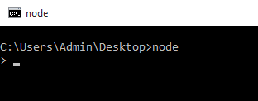

You can now write server-side JavaScript in this REPL (Read Eval Print Loop) environment.

# Using Node in the Command Prompt

You can create variables and functions here just as if you were writing a .js script, however there are some points worth noting.

* Hitting enter will execute a line, to drop down onto a new line (for a function for instance) use *ctrl+enter*
* In the Command Prompt it will try to output the returned result of what it executes, even if there is no return statement, this is why you will often see *undefined*.

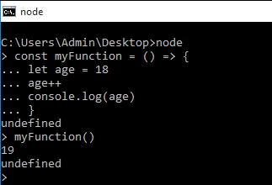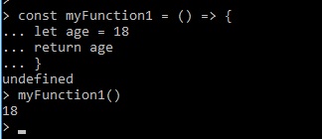

# Exercises

1. Experiment with this REPL to become familiar with its operation.
2. Can you save a variable?
3. Can you create and save a function that adds 2 numbers together?
4. Can you create a simple calculator (with only 4 operations) using multiple functions in the REPL.